John Rivera

Homework 8

Database Systems

1.

S1 : r1(X) r1(Y ) w2(Y ) w2(Z) r3(Z) w3(K) r2(K) w2(L) w1(X)

1. Potential Conflicts:

$$r_{1}\left(Y\right), w_{2}(Y)$$

$$w_{2}\left(Z\right), r_{3}\left(Z\right)$$

$$w_{3}\left(K\right), r_{2}(K)$$

Conflict Graph:

$$T_{2}$$

$$T_{1}$$

$$T_{3}$$

1. There is a cycle in the conflict graph, which means that these operations cannot occur in the same order as a serial schedule and S1 is therefore not serializable.

S2 : r1(X) w2(X) w1(Y ) r3(Y ) w3(Z) r2(Z) r3(W) w4(W) w2(Z) r4(W)

1. Potential Conflicts:

$$r_{1}\left(X\right), w_{2}(X)$$

$$w_{1}\left(Y\right), r_{3}\left(Y\right)$$

$$w_{3}\left(Z\right), r_{2}\left(Z\right)$$

$$w_{3}\left(Z\right), w_{2}\left(Z\right)$$

$$r_{3}\left(W\right), w_{4}\left(W\right)$$

Conflict Graph:

$$T_{4}$$

$$T_{2}$$

$$T_{1}$$

$$T_{3}$$

1. There is no cycle in the conflict graph, which means that there exists an equivalent serializable schedule:

$$T_{1}, T_{3}, T_{2}, T_{4}$$

2.

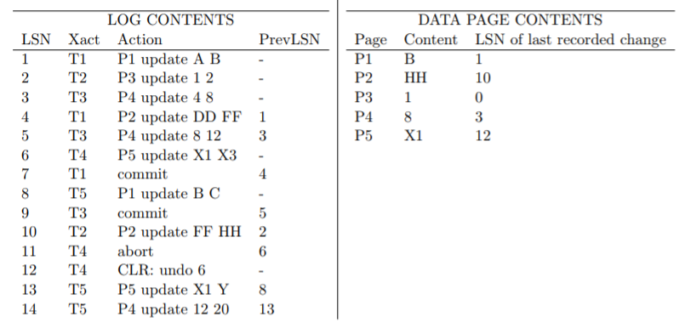

ANALYSIS Phase:

|  |  |  |
| --- | --- | --- |
| transaction | Last LSN |  |
| T1 | 7 | <committed> |
| T2 | 10 |  |
| T3 | 9 | <committed> |
| T4 | 12 | <abort> |
| T5 | 14 |  |

|  |  |
| --- | --- |
| Page | LSN |
| P1 | 1 |
| P3 | 2 |
| P4 | 3 |
| P2 | 4 |
| P5 | 6 |

Transaction Table (TT): DPT:

REDO Phase:

Only consider LSN’s with committed transactions that update or CLR

So test these LSN’s: 1, 3, 4, 5

Test LSN 1:

In DPT: P1, DPT_LSN = 1

LSN = 1 ≮ 1 = DPT_LSN

pageLSN = 1 = 1 = LSN

So do nothing

Test LSN 3:

In DPT: P4, DPT_LSN = 3

LSN = 3 ≮ 3 = DPT_LSN

pageLSN = 3 = 3 = LSN

So do nothing

Test LSN 4:

In DPT: P2, DPT_LSN = 4

LSN = 4 ≮ 4 = DPT_LSN

pageLSN = 10 > 4 = LSN

So do nothing

Test LSN 5:

In DPT: P4, DPT_LSN = 3

LSN = 5 ≮ 3 = DPT_LSN

pageLSN = 3 < 5 = LSN

REDO LSN 5

UNDO Phase:

Aborting T2, T4, T5

TO_UNDO = {10, 12, 14}

Write: UNDO 14 log record

P4 is already in memory but with pageLSN = 3

So no need to change the data page content as this update was never

written to disk

prevLSN = 13

TO_UNDO = {10, 12, 13}

Write: UNDO 13 log record

P5 is already in memory but with pageLSN = 12

So no need to change the data page content as this update was never

written to disk

prevLSN = 8

TO_UNDO = {10, 12, 8}

Write: UNDO 12 log record

prevLSN is NULL

write an end record for T4

TO_UNDO = {10, 8}

Write: UNDO 10 log record

P2 is already in memory with pageLSN = 10

So UNDO P2 contents and change it to FF

prevLSN = 2

TO_UNDO = {2, 8}

Write: UNDO 8 log record

P1 is already in memory with pageLSN = 1 < 8

So no need to change anything

prevLSN = NULL

write an end record for T5

TO_UNDO = {2}

Write: UNDO 2 log record

P3 is already in memory with pageLSN = 0 < 2

So no need to do anything

prevLSN = NULL

write an end record for T2

TO_UNDO = {}

Recovery Complete

3.

Query 10 plan before index:

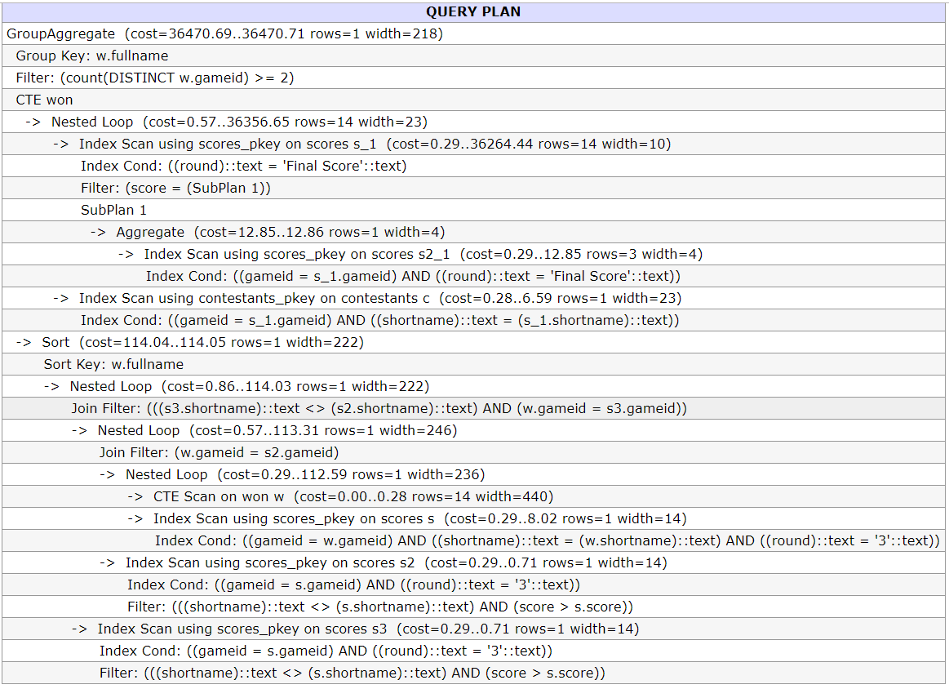

Created index:

create index scores_i1 on scores(round);

Query Plan after creating index:

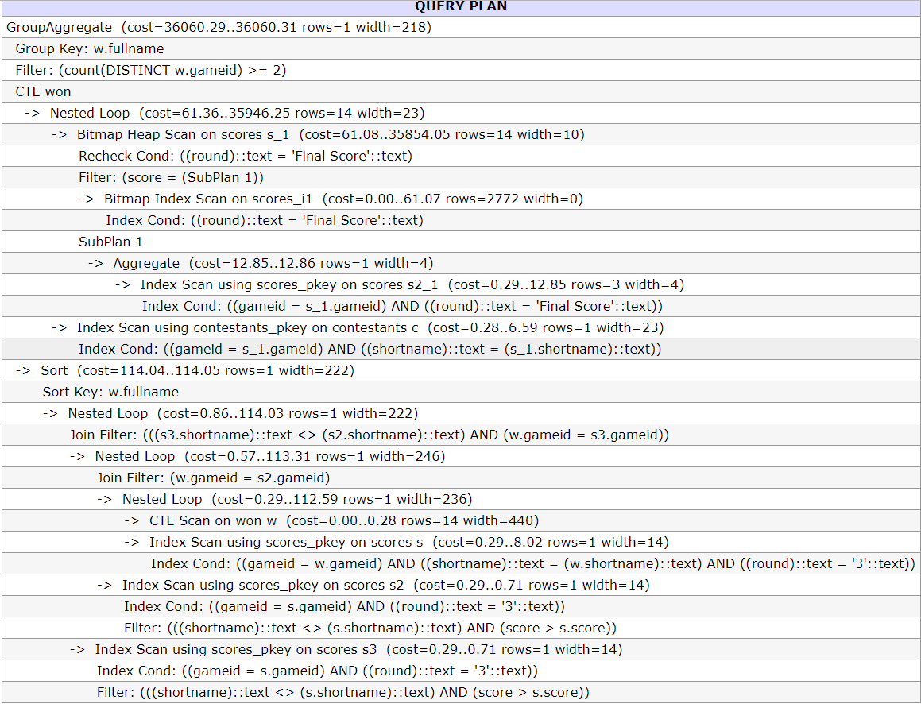

So savings are:

36470.71 – 36060.31 = 410.4